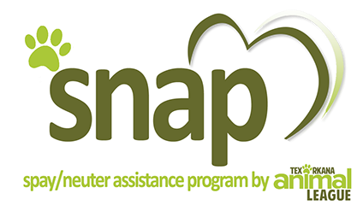

Dear pet owner,
Thank you for your interest in our Low-Cost Spay/Neuter Assistance Program (SNAP). TAL’s SNAP is designed to help pay the neutering costs for companion dogs and cats living with lower and/or fixed income households in Bowie, Cass, Little River, and Miller counties. Strays, rescue groups, and shelters are not currently eligible for this program.
The SNAP Application is two pages and requires a signature on both. Personal checks and money orders are acceptable forms of payments. Please do not send cash through the mail. If your application is not approved, your payment (in its original form) will be returned to you. The fee is $35 per cat and $50 per dog (no matter what size or age). Upon approval of your application, you will receive a packet detailing the steps for redeeming your certificate. Please keep in mind that your SNAP certificate is only good for 30 days.
This program is designed to provide your pet with (1) rabies vaccine prior to your pet being spayed or neutered and (2) the actual surgery. Any other treatments that your pet may need, for example flea/tick medication or heartworm treatment, are at your expense.
Please return your completed application, with the appropriate fee, to our mailing address for processing. If you have any questions, please call the number below or email us at snap@texarkanaanimalleague.org.
Application Checklist:
- Signed application (pages 1 and 2)
- Payment
- Proof of income or program
Sincerely,
Texarkana Animal League, Inc.
5820 Richmond Rd
Texarkana, TX 75503
877-525-4TAL
877-525-4825

Updated January 2020

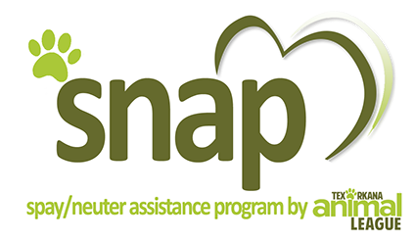
Spay and Neuter Assistance Program
Texarkana Animal League, Inc.
5820 Richmond Rd Texarkana TX 75503 877-525-4TAL 877-525-4825

Please print all information. Only one pet per application

Pet Owner Information:

Name

Home Address County

City State Zip Code

Home Phone # Other Phone #

Total number of persons living in your household

Total Annual Household Income
How often do you get paid: every week every other week once a month once a year

This information is kept COMPLETELY CONFIDENTIAL and will not be released to anyone other than TAL SNAP Committee Members who determine eligibility for this program. DOCUMENTATION OF CURRENT INCOME MUST BE ATTACHED. Proof of income examples (copies NOT originals): Benefits determination letter, recent Check Stub, recent Payroll
Check, W-2 statement, etc.

Pet Information (only one pet per application):

Type of Pet check only one: MALE DOG FEMALE DOG MALE CAT FEMALE CAT

Pet Name Breed

Color Age Weight

SIGNED AGREEMENT:

I HAVE READ AND UNDERSTAND THE ATTACHED TERMS AND CONDITIONS FOR THIS PROGRAM.

Signature of Pet Owner Date

Updated January 2020
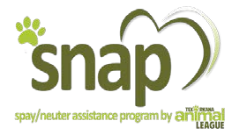
Terms and Conditions for the TAL Spay and Neuter Assistance Program
Texarkana Animal League, Inc.
5820 Richmond Rd Texarkana TX 75503
877-525-4TAL 877-525-4825
- The described pet lives at my home address, and I agree that a representative from Texarkana Animal League, Inc. may contact me and schedule a time to come to my home and verify this pet.
- I attest that the information provided is true and correct to the best of my knowledge.
- I hereby consent to the pre-surgical immunizations, if required, and the spay/neuter of the pet described on the application.
- I, as the pet owner, will be financially responsible for any additional treatment that the veterinarian deems medically necessary for the health of my pet, including but not limited to preop blood work, heartworm prevention, feline leukemia test or treatment, flea and tick treatment.
- Additional fees may be charged by the veterinarian and I will be responsible for them, if an animal is brought in for its procedure pregnant or in heat.
- The veterinarian reserves the right to postpone any procedure if the animal is not healthy enough to undergo surgery.
- Written proof of your pet’s vaccinations is required, if available, at the time of your appointment.
- Any abuse of this program, such as missed appointments, could be grounds for permanent removal from this program.
- I am a resident of Bowie, Cass, Little River, or Miller Counties.
- I understand that there is a limit on the number of times my household can apply for this program. Each household can apply for no more than 5 pets in a calendar year and 10 applications total for the life of the program. Each certificate is good for 30 days from the date issued and certificates are non-transferrable.
- Animals that are spayed or neutered and vaccinated as a result of the Spay/Neuter Assistance Program are the responsibility of the pet owner. I hereby agree that Texarkana Animal League, Inc. and the veterinarian performing surgery have no responsibility or liability for any injury or damage, or claims subsequent thereto, to any person, property, or animal caused directly or indirectly by any of the participating parties. I agree to participate in this program and agree to this waiver of liability.

Signature of Pet Owner Date
- Please return this form, supporting documentation, and your fee, $35 per cat or $50 per dogs to: Texarkana Animal League, Inc., 5820 Richmond Rd, Texarkana TX 75503.
- Please make all checks and money orders payable to: Texarkana Animal League – SNAP.
- You will receive a packet by mail, if approved, after your application has been processed. If your application is not approved, your fee will be returned to you.

Thank you for taking the first step in helping the pet over-population problem in our area.
Updated January 2020

